**PIZZA SALES SQL QUERIES**

**KPI’S**

**1. Total Revenue:**

SELECT SUM(total_price) AS Total_Revenue FROM pizza_sales;

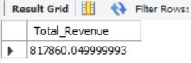

**2. Average Order Value**

select sum(total_price)/count(distinct order_id) AS Average_order_values from pizza_sales;

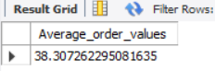

1. **Total Pizzas Sold**

select sum(quantity) as total_pizza_sold from pizza_sales;

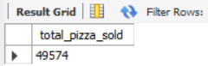

1. **Total Orders**

select count(distinct order_id) as total_orders from pizza_sales;

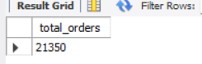

**5. Average Pizzas Per Order**

select cast(cast(sum(quantity) as decimal (10,2)) /

cast(count(distinct order_id) as decimal(10,2)) as decimal (10,2)) as avg_pizza_per_order from pizza_sales;

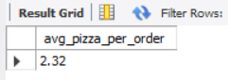

**CHART REQUIREMENT**

**1. Daily Trend for total Orders.**

SELECT DAYNAME(order_date) AS order_day, COUNT(DISTINCT order_id) AS total_orders

FROM pizza_sales

GROUP BY DAYNAME(order_date);

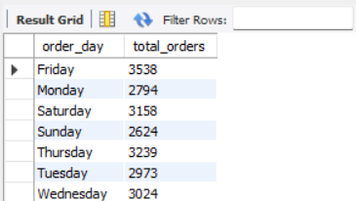

1. **Monthly Trend for total Orders.**

select monthname(order_date) as order_month, count(distinct order_id) as total_orders

from pizza_sales

group by monthname(order_date)

order by total_orders desc;

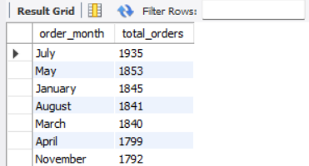

1. **Percentage of sales by Pizzas category.**

select pizza_category, sum(total_price)*100 /(select sum(total_price)from pizza_sales where month(order_date) = 1) as percent_for_total_Sales

from pizza_sales

where month(order_date) = 1 group by pizza_category;

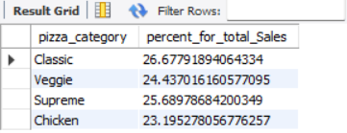

1. **Percentage of sales by Pizzas size.**

SELECT pizza_size, CAST(SUM(total_price) * 100 / (SELECT SUM(total_price) from pizza_sales) AS DECIMAL(10,2)) AS PCT

FROM pizza_sales

GROUP BY pizza_size;

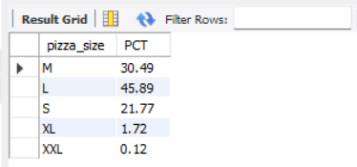

1. **Top 5 pizza by revenue.**

select pizza_name, sum(total_price) as total_revenue from pizza_sales

group by pizza_name

order by total_revenue desc

limit 5;

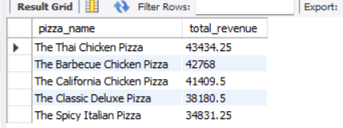

1. **Bottom 5 pizza by revenue.**

select pizza_name,sum(total_price) as total_revenue from pizza_sales

group by pizza_name

order by total_revenue asc

limit 5;

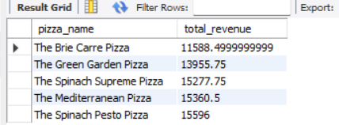

1. **Top 5 pizza by orders.**

SELECT pizza_name, COUNT(DISTINCT order_id) AS Total_Orders

FROM pizza_sales

GROUP BY pizza_name

ORDER BY Total_Orders DESC

limit 5;

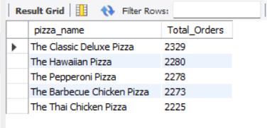

1. **Bottom 5 pizza by orders.**

SELECT pizza_name, COUNT(DISTINCT order_id) AS Total_Orders

FROM pizza_sales

GROUP BY pizza_name

ORDER BY Total_Orders asc

limit 5;

